Institute of Information Technology (IIT)

Jahangirnagar University



# Lab Report: 01 Course Code: ICT-4104

Submitted by:

Name: Md. Shakil Hossain

Roll No: 2023

Lab Date: 29.05.2023

Submission Date: 12.06.2023

**Name of Experiment:** Change of reconstructed signal when we change sampling signal in time domain.

# Theory:

## Nyquist Theorem:

The Nyquist-Shannon sampling theorem, often referred to as the Nyquist theorem or Nyquist criterion, is a fundamental concept in digital signal processing. It provides a guideline for the minimum sampling rate required to accurately represent a continuous-time signal in the digital domain.

According to the Nyquist theorem, if a continuous-time signal has a bandwidth limited to a maximum frequency component of B Hertz, then it must be sampled at a rate of at least 2B samples per second to avoid aliasing. In other words, the sampling rate should be at least twice the maximum frequency present in the signal.

Aliasing is a phenomenon that occurs when a high-frequency signal is improperly sampled at a rate that is too low. It results in the creation of false low-frequency components in the digital representation of the signal, leading to distortion and loss of information.

To avoid aliasing and accurately reconstruct the original signal, the Nyquist theorem sets the minimum sampling rate at twice the bandwidth (2B) of the signal. This sampling rate is often referred to as the Nyquist rate.

𝐹𝑠 > 2𝐹𝑚

Where,

Fs= Sampling frequency;

Fm= Maximum frequency of input signal.

It's important to note that the Nyquist theorem assumes ideal conditions, such as infinite signal duration and perfect low-pass filtering before sampling. In practical applications, it is common to choose a sampling rate higher than the Nyquist rate to provide a safety margin and accommodate for imperfections in the system.

## Signal Reconstruction:

Signal reconstruction refers to the process of accurately reconstructing a continuous-time signal from its discrete samples. It is necessary when a continuous-time signal is digitised by sampling it at a certain rate, according to the Nyquist-Shannon sampling theorem.

To reconstruct a continuous-time signal from its discrete samples, interpolation techniques are commonly used. Interpolation involves estimating the values of the continuous-time signal at points between the sampled data points.

One commonly used interpolation technique is the ideal low-pass filter, also known as the zero-order hold (ZOH) or the Sinc interpolation. The ideal low-pass filter assumes that the original continuous-time signal was band-limited with a cutoff frequency less than or equal to the Nyquist frequency. The process involves convolving the discrete samples with the Sinc function and then applying a low-pass filter to remove the high-frequency components. The resulting continuous-time signal closely approximates the original signal.

Another interpolation technique is polynomial interpolation, where a polynomial function is fitted to the discrete samples. Polynomial interpolation methods include Lagrange interpolation and Newton interpolation, among others. These methods use polynomial functions to estimate the values between the sampled points based on the given data.

In addition to these techniques, there are other advanced interpolation methods used in practice, such as spline interpolation and wavelet interpolation. These methods offer different trade-offs between accuracy, complexity, and computational requirements.

It's important to note that the accuracy of the reconstructed signal depends on various factors, including the sampling rate, the quality of the interpolation method used, and any noise or distortion introduced during the sampling process. To achieve high-quality signal reconstruction, it is often necessary to choose a sampling rate higher than the Nyquist rate and use advanced interpolation techniques that minimise interpolation errors.

Signal reconstruction is a crucial step in DSP, as it allows for the conversion of discrete digital signals back into a continuous-time representation for further processing, analysis, or playback in analog systems.

# Code:

## Problem 1: Validation of Nyquist Theorem

A=1 ;F=1; theta =0; dt=0.0001;

t = 0:dt:1;

x_a= A *sin(2*pi*F*t +theta);

subplot(3,1,1) plot(t,x_a); xlabel('time (sec)');

ylabel('x_a');

title('Analogue (Continuous) Input Signal', 'Linewidth',5);

F_s = 6*F;T_s =1/F_s; n = F_s;

n_1 = 0:T_s:n*T_s;

x_s = A*sin(2*pi*F*n_1 + theta); subplot(3,1,2)

stem(n_1,x_s); xlabel('sampling (n)');

ylabel('x_s');

title('Discrete Time Signal','LineWidth',5);

t_1=linspace(0,max(n_1),(max(n_1)/dt)); x_r = interp1(n_1,x_s,t_1,'spline'); subplot(3,1,3)

plot(t_1,x_r); xlabel('time (sec)');

ylabel('x_r');

title('reconstructed signal','LineWidth',5)

## Problem 2: Two different waveforms and repeat.

A=10;F=2; theta =0.5; dt=0.001;

t = 0:dt:1;

x_a= A*sin(2*pi*F*t +theta);

subplot(3,1,1) plot(t,x_a); xlabel('time (sec)');

ylabel('x_a');

title('Analogue (Continuous) Input Signal', 'Linewidth',5); F_s = 1.5*F;T_s =1/F_s;

n = F_s;

n_1 = 0:T_s:n*T_s;

x_s = A*sin(2*pi*F*n_1 + theta); subplot(3,1,2)

stem(n_1,x_s); xlabel('sampling (n)');

ylabel('x_s');

title('Discrete Time Signal','LineWidth',5);

t_1=linspace(0,max(n_1),(max(n_1)/dt)); x_r = interp1(n_1,x_s,t_1,'spline'); subplot(3,1,3)

plot(t_1,x_r); xlabel('time (sec)');

ylabel('x_r');

title('reconstructed signal','LineWidth',5)

# Result:

## Problem 1: Validation of Nyquist Theorem

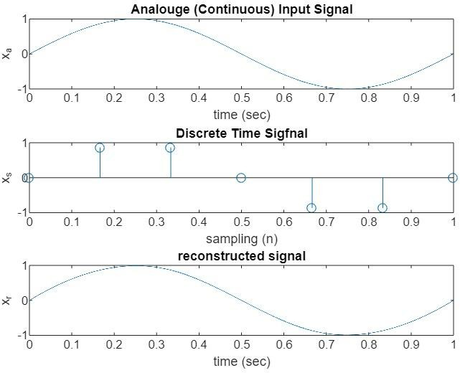

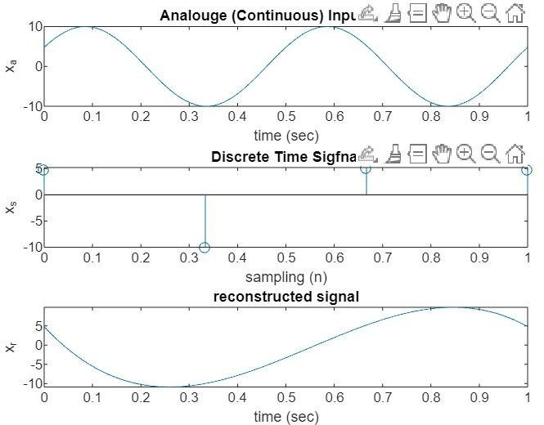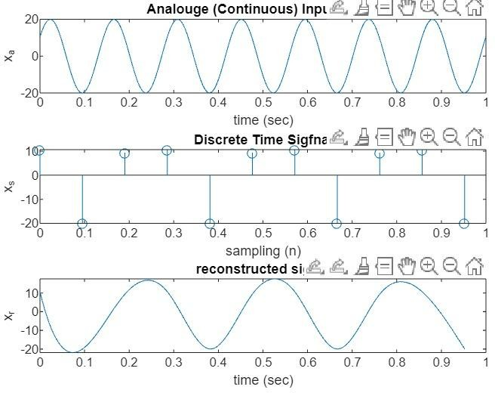Problem 2: Two different waveforms and repeat.

# Discussion:

The Nyquist theorem states that in order to accurately reconstruct a continuous-time signal from its samples, the sampling frequency must be at least twice the maximum frequency present in the signal. To validate the Nyquist theorem for a given signal, I have to check if the sampling frequency satisfies the Nyquist. It calculates the maximum frequency present in the signal using the max_frequency/2 predicate. Then, it checks if the sampling frequency is greater than or equal to twice the maximum frequency as per the Nyquist theorem. According to our work our analog signal and reconstructed signal is quite similar having the 2*max frequency of original signal. Different values of amplitudes,frequency and theta we get different waveforms of and they are also followed by Nyquist Theorem.